Nama : Millatina Silmi

NIM :

Judul: Sistem Informasi Arsip SPM

Fitur-fitur:

1. LOGIN
   1. ADMIN
      * NIP
      * Nama
      * Password
      * Hak Akses
   2. PEGAWAI
      * NIP
      * Nama
      * Password
      * Hak Akses
2. Manajemen Data
   1. INPUT DATA
      * Nomor SPM
      * Nama Seksi
      * Tanggal SPM
      * Nominal SPM
      * Klasifikasi Pembayaran
      * Uraian SPM
      * Lokasi Rak
      * Upload Dokumen
   2. UPDATE DATA
      * Nominal SPM
      * Uraian SPM
      * Detail Pembayaran
      * Upload Dokumen
   3. DELETE DATA
      * Hapus Data
3. Search Data
4. Berdasarkan nomor SPM
5. Berdasarkan Nama Seksi
6. Berdasarkan Klasifikasi Pembayaran
7. Kelola RAK
   1. Tambah Data Rak
      * Nomor Rak
   2. Hapus Data Rak

* Nomor Rak

UML

1. *Use Case Diagram*

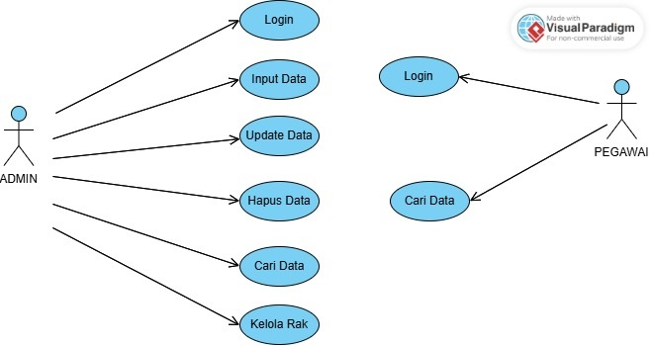

*Use Case Diagram*

1. *Activity Diagram*

* *Login*

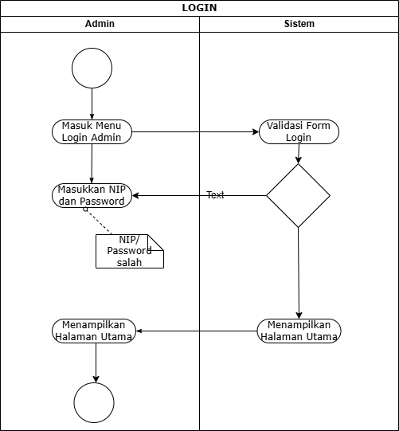

*Activity Diagram Login*

* Input Data

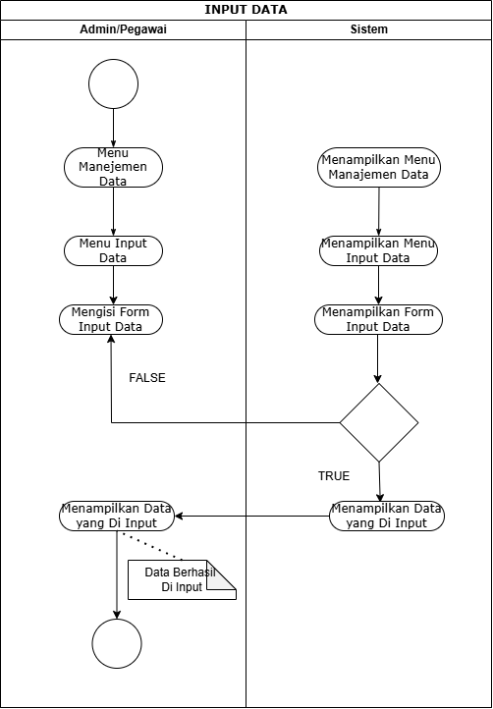

*Activity Diagram Input Data*

* Update Data

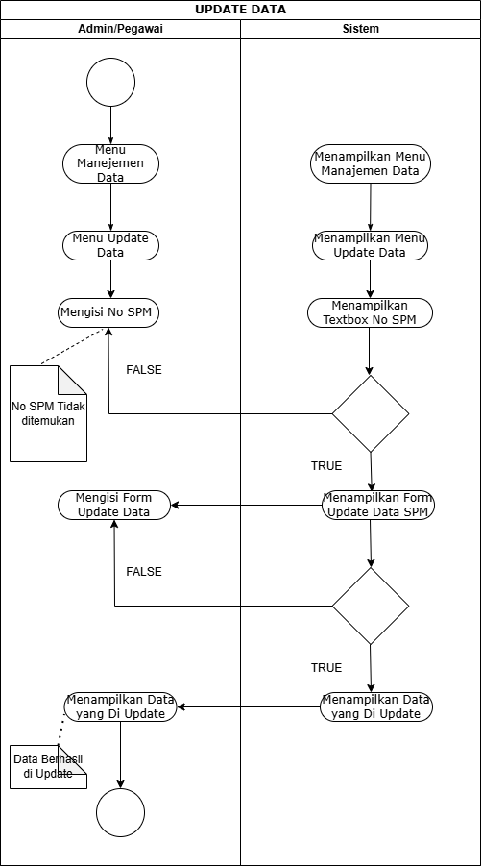

*Activity Diagram Update Data*

* Search Data By No SPM

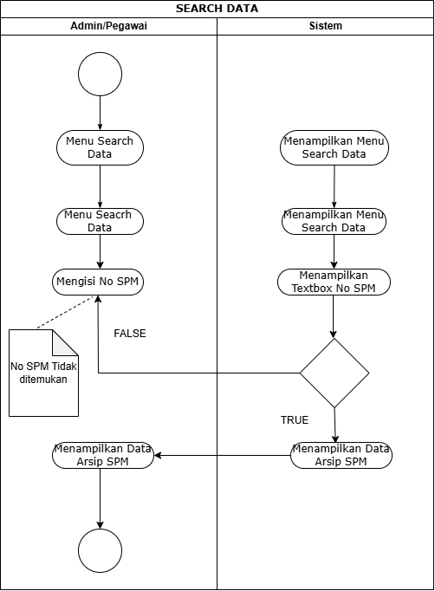

*Activity Diagram by No SPM*

* Seacrh Data by Seksi

*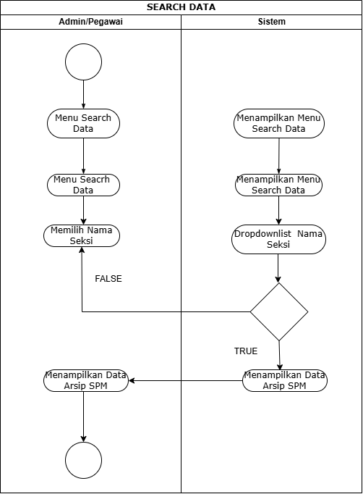*

*Activity Diagram Search Data by Seksi*

* *Search Data by Date*

*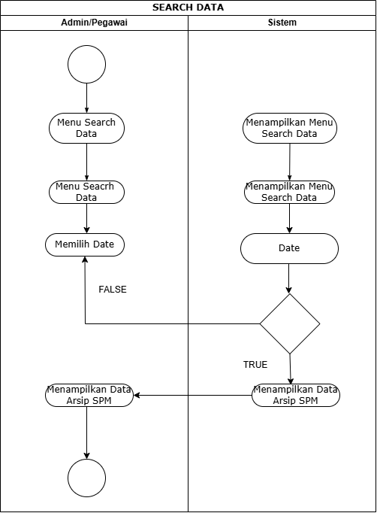*

*Activity Diagram Search Data by Date*

* Activity Diagram Delete Data

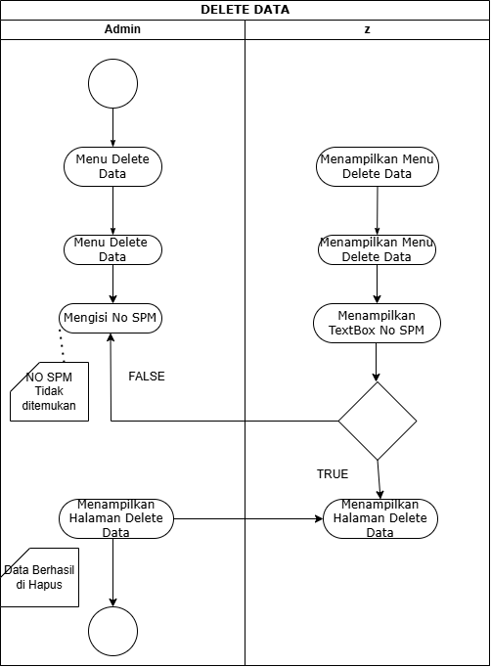

*Activity Diagram Delete Data*

* Kelola Rak( Tambah Nomor Rak)

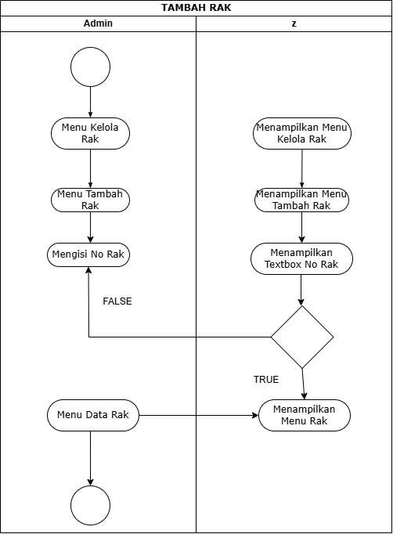

*Activity Diagram* Tambah Nomor Rak

* Activity Diagram Delete No Rak

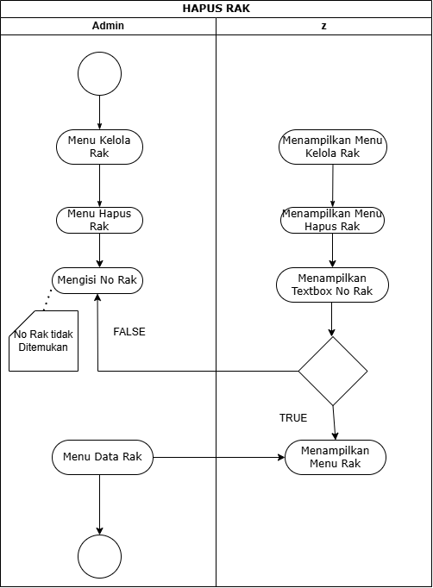

*Activity Diagram Hapus No Rak*

* *Sequence Diagram*

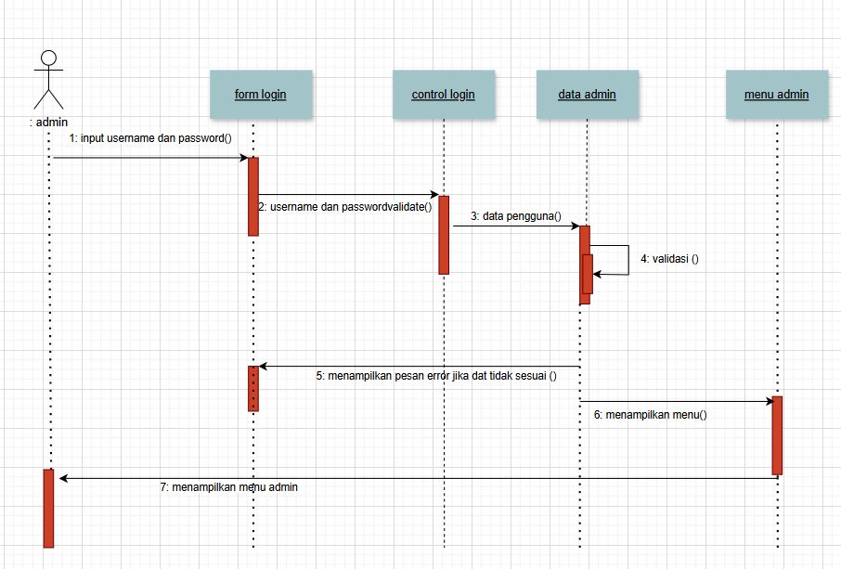

*Sequence diagram login*

*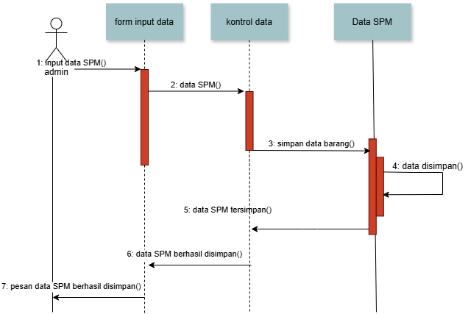*

*Sequence Diagram Input Data SPM*

* *Class Diagram*

*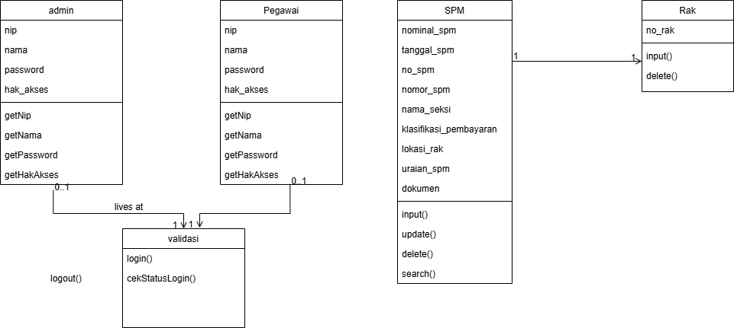*

*Class Diagram*